Inquiry Frequently Asked Questions Doc(IFAQ Doc)
Dear customer
In order to provide you with an accurate quotation and the best solution, please answer the following questions. Thank you!

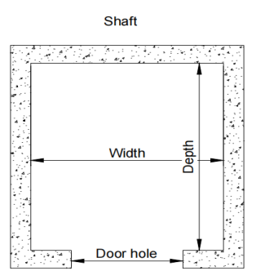
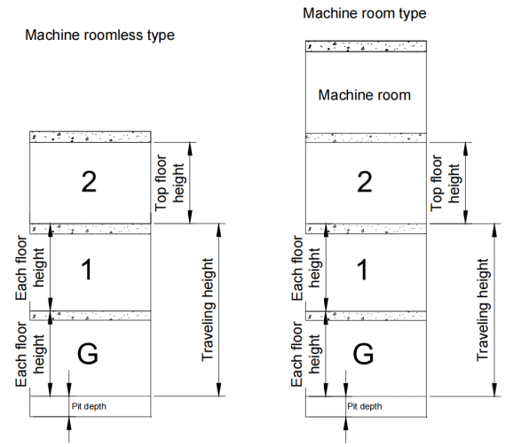
1.Please provide the parameters required for the quotation (* indicates mandatory parameters; for others, if not specified, we will temporarily use our standard specifications).

①*shaft size:（WidthxDepth) :
②*Number of floors:
③*Machine room or Machine roomless
④Traveling height or Each floor height
⑤Pit depth and Top floor height

2.What’s the project name?

3.Is this your first time purchasing an elevator(Escalator)?
A. Yes B. No

4.What industry are you engaged in?
A. Elevator B. Construction C. Real Estate D. Other(.....)

5.What is your role?
A. Business Owner B. Procurement Officer C. Engineer D. Sales Representative E. End User

6.What is the intended usage scenario for this elevator?
A. Office Building B. Hotel C. Shopping Mall D. Residential Home E. Other(.....)

7.What is the current status of the elevator shaft?
A. Fully Completed B. Partially Completed (elevator shaft topping-out not yet completed)
C. Not Started (if so, approximately when will construction begin?)

8.When is the planned procurement period for the elevator?
A.Within 1 Month B. Within 2 Months C. Within 3 Months D. Within 6 Months
E. Other(.....)

Noted:If you have any additional requirements, please let us know as well.
Please give your options separately,Thank you!

